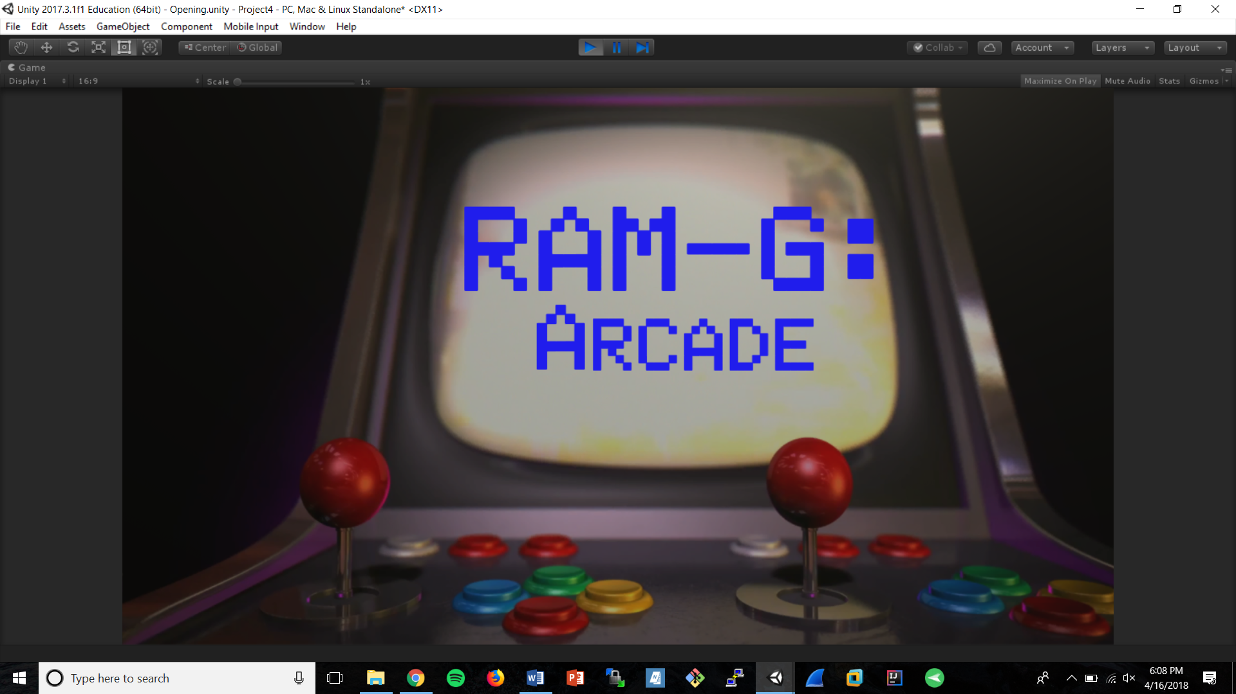

***Game Design Document (GDD)***

*‘Yo Pierre, you wanna play these games?’* - Two Bres, Two Brothas

|  |  |  |
| --- | --- | --- |
| Table of Contents  [1 Game Overview](https://n-xovwktmtjsnaxyc2mwes2xu7pohqedmdm6zjw5q-2lu-script.googleusercontent.com/userCodeAppPanel)  [2 High Concept](https://n-xovwktmtjsnaxyc2mwes2xu7pohqedmdm6zjw5q-2lu-script.googleusercontent.com/userCodeAppPanel)  [3 Synopsis](https://n-xovwktmtjsnaxyc2mwes2xu7pohqedmdm6zjw5q-2lu-script.googleusercontent.com/userCodeAppPanel)  [4 Game Objectives](https://n-xovwktmtjsnaxyc2mwes2xu7pohqedmdm6zjw5q-2lu-script.googleusercontent.com/userCodeAppPanel)  [5 Game Rules](https://n-xovwktmtjsnaxyc2mwes2xu7pohqedmdm6zjw5q-2lu-script.googleusercontent.com/userCodeAppPanel)  [6 Game Play](https://n-xovwktmtjsnaxyc2mwes2xu7pohqedmdm6zjw5q-2lu-script.googleusercontent.com/userCodeAppPanel)  [6.1 Game Controls](https://n-xovwktmtjsnaxyc2mwes2xu7pohqedmdm6zjw5q-2lu-script.googleusercontent.com/userCodeAppPanel)  [6.2 Maps](https://n-xovwktmtjsnaxyc2mwes2xu7pohqedmdm6zjw5q-2lu-script.googleusercontent.com/userCodeAppPanel)  [7 Players](https://n-xovwktmtjsnaxyc2mwes2xu7pohqedmdm6zjw5q-2lu-script.googleusercontent.com/userCodeAppPanel)  [7.1 Characters](https://n-xovwktmtjsnaxyc2mwes2xu7pohqedmdm6zjw5q-2lu-script.googleusercontent.com/userCodeAppPanel)  [7.2 Metrics](https://n-xovwktmtjsnaxyc2mwes2xu7pohqedmdm6zjw5q-2lu-script.googleusercontent.com/userCodeAppPanel)  [7.3 States](https://n-xovwktmtjsnaxyc2mwes2xu7pohqedmdm6zjw5q-2lu-script.googleusercontent.com/userCodeAppPanel)  [7.4 Weapons](https://n-xovwktmtjsnaxyc2mwes2xu7pohqedmdm6zjw5q-2lu-script.googleusercontent.com/userCodeAppPanel)  [8 NPC](https://n-xovwktmtjsnaxyc2mwes2xu7pohqedmdm6zjw5q-2lu-script.googleusercontent.com/userCodeAppPanel)  [8.1 Enemies](https://n-xovwktmtjsnaxyc2mwes2xu7pohqedmdm6zjw5q-2lu-script.googleusercontent.com/userCodeAppPanel)  [8.1.1 Enemy States](https://n-xovwktmtjsnaxyc2mwes2xu7pohqedmdm6zjw5q-2lu-script.googleusercontent.com/userCodeAppPanel)  [8.1.2 Enemy Spawn Points](https://n-xovwktmtjsnaxyc2mwes2xu7pohqedmdm6zjw5q-2lu-script.googleusercontent.com/userCodeAppPanel)  [8.2 Allies / Companions](https://n-xovwktmtjsnaxyc2mwes2xu7pohqedmdm6zjw5q-2lu-script.googleusercontent.com/userCodeAppPanel)  [8.2.1 Ally States](https://n-xovwktmtjsnaxyc2mwes2xu7pohqedmdm6zjw5q-2lu-script.googleusercontent.com/userCodeAppPanel)  [8.2.2 Ally Spawn Points](https://n-xovwktmtjsnaxyc2mwes2xu7pohqedmdm6zjw5q-2lu-script.googleusercontent.com/userCodeAppPanel)  [9 Art](https://n-xovwktmtjsnaxyc2mwes2xu7pohqedmdm6zjw5q-2lu-script.googleusercontent.com/userCodeAppPanel)  [9.1 Setting](https://n-xovwktmtjsnaxyc2mwes2xu7pohqedmdm6zjw5q-2lu-script.googleusercontent.com/userCodeAppPanel)  [9.2 Level Design](https://n-xovwktmtjsnaxyc2mwes2xu7pohqedmdm6zjw5q-2lu-script.googleusercontent.com/userCodeAppPanel)  [9.3 Audio](https://n-xovwktmtjsnaxyc2mwes2xu7pohqedmdm6zjw5q-2lu-script.googleusercontent.com/userCodeAppPanel)  9.4 What you Developed     |  | | --- | |  | | Game Development Team Members    PRODUCER  Samuel Akinmulero    PRODUCTION MANAGER  Breanna Bergado    PRODUCTION COORDINATOR  Ricky Roots    GAME DESIGNERS  Brittany Saunders    SYSTEMS/IT COORDINATOR  Samuel Akinmulero    PROGRAMMERS  Ricky Roots    TECHNICAL ARTISTS  Brittany Saunders    AUDIO ENGINEERS  Breanna Bergado    UX TESTERS  Ricky Roots |

|  |
| --- |
|  |

# **1 Game Overview \***

Title: Random (Awesome/Ass) Mini-Games: Arcade

Platform: PC, Mac

Genre: Arcade, Adventure

Rating: (10+) ESRB

Target: Casual gamer

Retro gamer

Release date: May 3, 2018

Publisher: Two Bres, Two Brothas

Description: Our game is a multiplayer game that takes place in an arcade. The player is able to go up to the different arcade machines and enter a Network Multiplayer Lobby to play the different games. There are 3 different games,

# **2 High Concept\***

Ram-G Arcade sets the player in an Arcade where the player has the choice to walk up to different Arcade Machines and play the game of their choice. The player will enter a lobby for each of the games to be matched with other players who are also wishing to play the game.

# **3 Synopsis\***

You finally graduated college with a degree in Computer Science and you have no idea what to do with your summer…. You decided to head down to the local arcade play games against your other fellow graduates before you have to slave the rest of your life away working.

# **4 Game Objectives\***

The objective of this game is to play the different arcade games and beat your friends.

# **5 Game Rules\***

Ricky’s Game -

Brit’s Game -

JetGame - Dodge the PGC while keeping the camera adjusted properly

# **6 Game Play\***

# **6.1 Game Controls**

**Arcade Scene Controls**:



## 

## 



### **6.2 Maps**

# **7 Players (optional)**

## **7.1 Characters**

1. SlenderBear

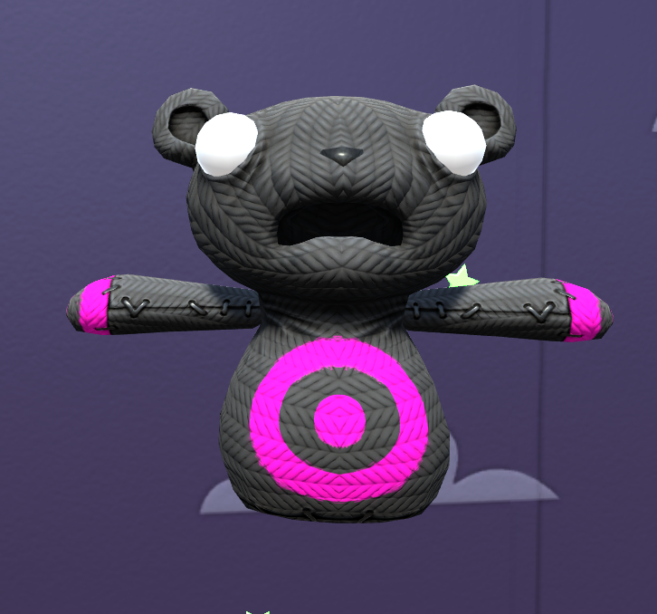

1. Brit’s
2. Sam’s

## **7.2 Metrics**

1. SlenderBear
   * Player walk speed: 2.5
   * Player Run speed: 5
   * SlenderBear run speed: 5.8
2. Brit’s
3. Sam’s

## **7.3 States**

1. SlenderBear
   * SlenderBear has 3 States:
     + Search: He is looking for you!
     + Chase: When the player is spotted, he Charges towards you at full speed!
     + Kill: When he reaches you… RIP
2. Brit’s
3. Sam’s

## **7.4 Weapons**

1. SlenderBear
   * N/A
2. Brit’s
3. Sam’s
   * N/A

# **8 NPC (optional)**

## **8.1 Enemies**

1. SlenderBear



1. Brit’s
2. Sam’s

### **8.1.1 Enemy States**

1. Ricky’s
2. Brit’s
3. Sam’s

### **8.1.2 Enemy Spawn Points**

1. Ricky’s
2. Brit’s
3. JetGame - Enemies spawn on player

# **9 Art \***

## **9.1 Setting**

The game takes place in the Arcade. The machines depict what games are multiplayer and which is a single player.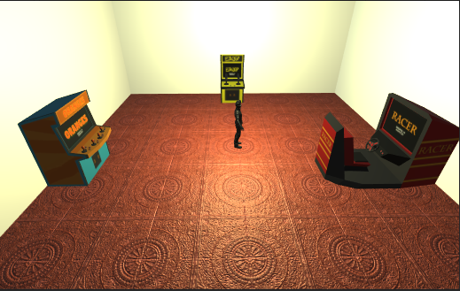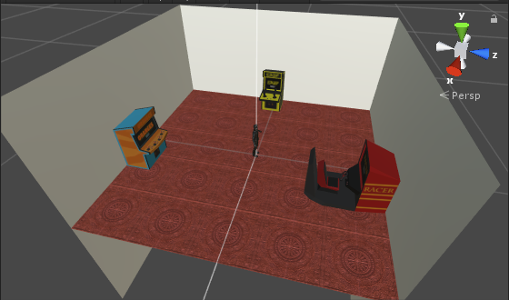

## 

## **9.2 Level Design**

SlenderBear

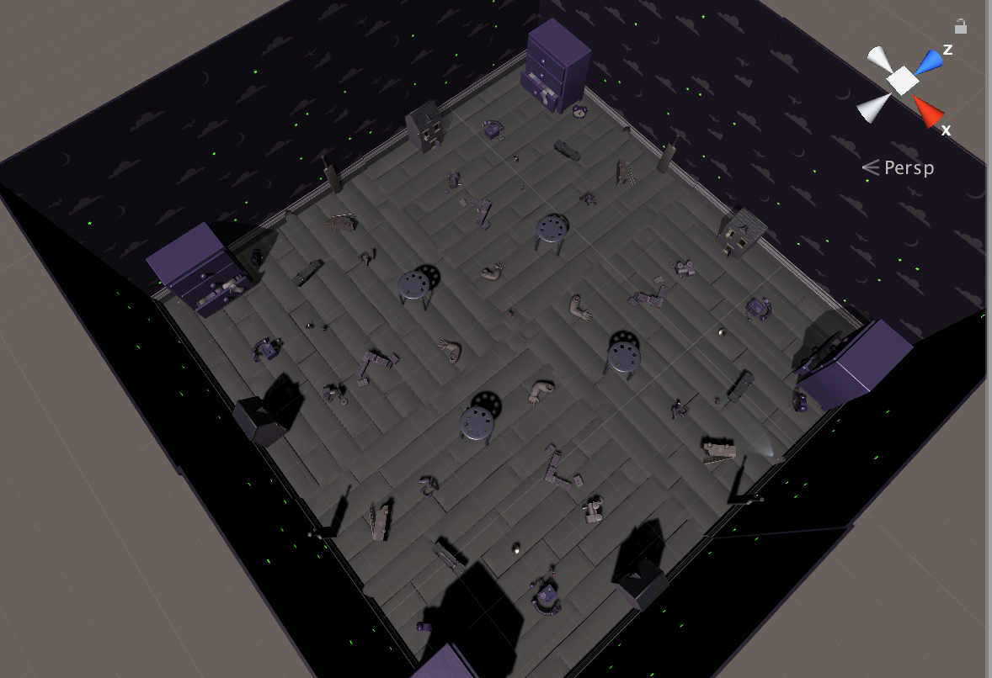

## JetGame

## 

## **9.3 Audio**

|  |  |  |
| --- | --- | --- |
| Name | Category | Description |
| DoThatIsh! Instrumental | Background Music | Plays during JetGame Lobby Scene |
| Magnolia Instrumental | Background Music | Plays during JetGame Scene |
| BackgroundMusic | Background Music | Plays during SlenderBear Scene |
|  |  |  |
|  |  |  |
|  |  |  |
|  |  |  |
|  |  |  |
|  |  |  |

## **9.4 What you Developed**

Samuel Akinmulero - The Entire JetGame

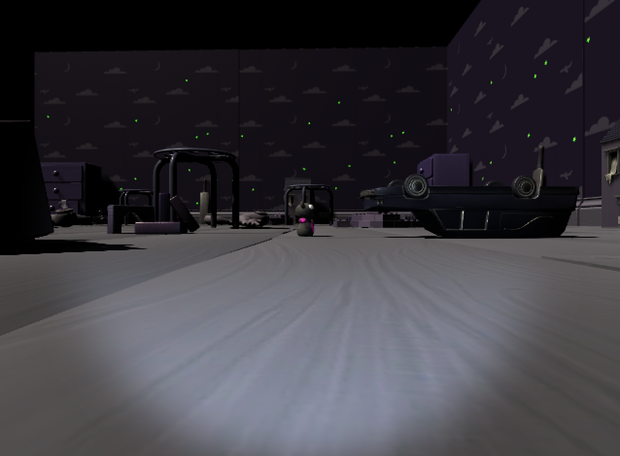

Ricky’s Slenderbear:

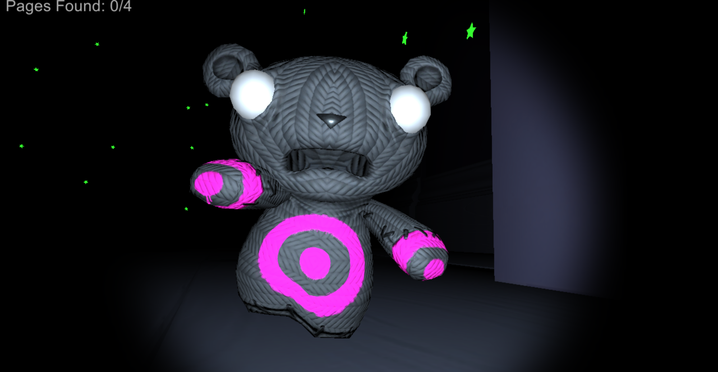

Brittany’s ObstacleRace

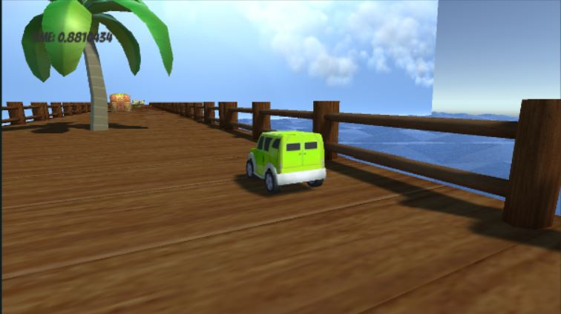

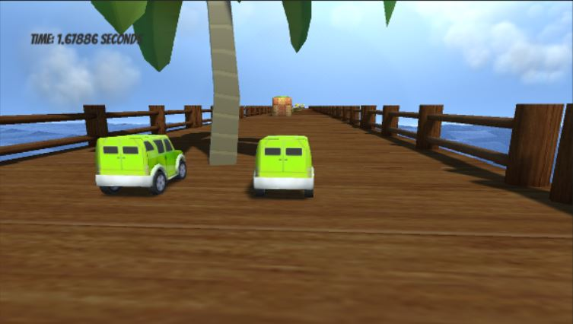

Assets Downloaded:

Sources for SlenderBear

* Unity Survival Shooter Pack

https://unity3d.com/learn/tutorials/s/survival-shooter-tutorial

***Sources for JetGame***

**Scripts*:***

**Game Timer Script-****<https://www.youtube.com/watch?v=ixlIaMuhkbM>**

**Object Color Script -****<https://answers.unity.com/questions/389027/how-do-you-change-the-color-of-an-obect-cube-cylin.html>**

**Spawn Objects Script -****<https://answers.unity.com/questions/898380/spawning-an-object-at-a-random-time-c.html>**

**Follow Target Script -****<https://forum.unity.com/threads/c-ai-follow-chase.319332/>**

[**https://www.youtube.com/watch?v=7S9paunWus4**](https://www.youtube.com/watch?v=7S9paunWus4) **– Network Lobby Scripts, SetupLocalPlayer Scripts**

[**https://www.youtube.com/watch?v=wvUNXkrEMys**](https://www.youtube.com/watch?v=wvUNXkrEMys) **– Camera Follow Script**

**Music:**

**DothatIsh! Instrumental :****<https://www.youtube.com/watch?v=cS9-nMQnSV0>**

**Magnolia Instrumental:** [**https://soundcloud.com/dosagebeatss/playboi-carti-magnolia-instrumental-prod-dose**](https://soundcloud.com/dosagebeatss/playboi-carti-magnolia-instrumental-prod-dose)

**Assets:**

**<https://assetstore.unity.com/packages/2d/textures-materials/sky/cope-free-skybox-pack-22252>**

**Unity Standard Asset Package**

**18 Free Skybox Package -****<https://forum.unity.com/threads/18-free-skyboxes-unitypackage.27513/>**

**<https://assetstore.unity.com/packages/essentials/beta-projects/textmesh-pro-84126>**

**Text Mesh Pro**

**Lobby:****<https://www.youtube.com/watch?v=7S9paunWus4>**

**Brittany’s Assets**

Concrete Barrier, Wooden Pallet & Oil Drum Props 1.0 – Duane’s Mind

Car 3.3.2 – Cactuscreatives Pvt. Ltd.

Road Blocker 4.0 – Rakshi Games

Grass Road Race 1.1 – Sugar Asset

Rock & Boulders 1.2 – Manufactura K4

SkySphere Volume 1 1.0 – Hedgehog Team

TextMesh Pro 1.0.56.0b2 – Unity Technologies